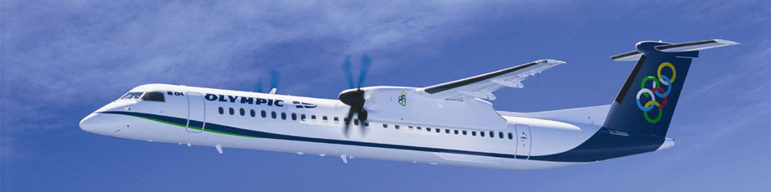

Olympic Airplane Routes

FROM 27/3/2016 - 29/10/2016
ATHENS - KITHIRA / KITHIRA - ATHENS EVERY DAY 14.30 / 15.40
SUNDAY 08.00 & 14.30 / 09.10 & 15.40
FROM 03/06/2016 - 09/09/2016
ATHENS - KITHIRA / KITHIRA - ATHENS EVERY DAY 14.30 / 15.40
FRIDAY 08.00 & 14.30 / 09.10 & 15.40
SUNDAY 08.00 & 14.30 / 09.10 & 15.40

" Flight Information Must Be Confirmed Before Departure"
Athens to Kythera are operated by Olympic Air
Τel: +30 2103550500 και 801.801.0101
http://www.olympicair.com

OLYMPIC AIR
Tel.: +30 2736033292 Phone no: +30 2736033292 Fax: +30 2736033688

