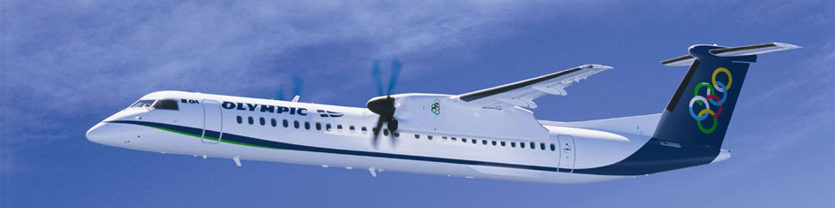

Olympic Airplane Routes

DAY | ATHENS – KYTHIRA | KYTHIRA – ATHENS
SUNDAY | 17:55 – 18:40 | 19:05 – 19:45
from 24.06 to 22.07 | 13:20 – 14:10 | 14:35 – 15:20
MONDAY | 17:55 – 18:40 | 19:05 – 19:45
TUESDAY | 17:55 – 18:40 | 19:05 – 19:45
WEDNESDAY | 07:30 – 08:20 | 08:40 – 09:25
from 27.06 to 25.07 | 13:20 – 14:10 | 14:35 – 15:20
THURSDAY | 17:55 – 18:40 | 19:05 – 19:45
FRIDAY | 07:30 – 08:20 | 08:40 – 09:25
FRIDAY | 13:20 – 14:10 | 14:35 – 15:20
SATURDAY | 17:55 – 18:40 | 19:05 – 19:45
01.06.2018 – 30.09.2018

DAY | ATHENS – KYTHIRA | KYTHIRA – ATHENS
SUNDAY | 07:30 – 08:20 | 08:40 – 09:25
MONDAY | 07:30 – 08:20 | 08:40 – 09:25
WEDNESDAY | 07:30 – 08:20 | 08:40 – 09:25
FRIDAY | 07:30 – 08:20 | 08:40 – 09:25
01.10.2018 – 12.10.2018

SINGLE TRIP ATHENS – KYTHIRA | SINGLE TRIP KYTHIRA – ATHENS | RETURN TRIP ATHENS – KYTHIRA
High season fare *
€ 114,18 | € 92,30 | € 206,48
Mid season high fare*
€ 97,18 | € 75,30 | € 172,48
Mid season low fare *
€ 65,18 | € 43,30 | € 108,48
Low season fare*
€ 41,18 | € 19,30 | € 60,48
FARES OLYMPIC AIR
Olympic Air * 8 kg handbaggage and 23 kg baggage
Always check the website of Olympic Air for the latest information on availability and prices.

Timetable is subject to change !
www.olympicair.com

Flight booking online
" Flight Information Must Be Confirmed Before Departure"
Athens to Kythera are operated by Olympic Air
Τel: +30 2103550500 και 801.801.0101
OLYMPIC AIR
Tel.: +30 2736033292 Phone no: +30 2736033292 Fax: +30 2736033688

