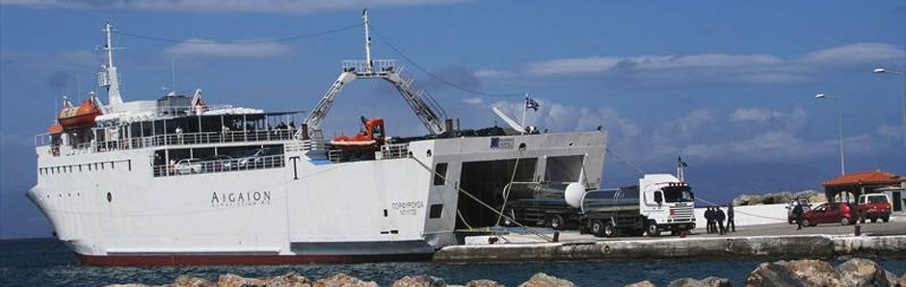
ROUTES F/B PORFYROUSA

Neapolis-Kythera
Monday 09.00
Tuesday 12.30
Wednesday -
Thursday 09.00
Friday 14.30
Saturday 10.00
Sunday 11.00

Kythera-Neapolis
Monday 16.00
Tuesday 16.00
Wednesday -
Thursday 16.00
Friday 16.15
Saturday 14.00
Sunday 14.00

From 15/6/2018 until 19/7/2018

Neapolis-Kythera
Monday 09.00
Tuesday 12.30
Wednesday 09.30
Thursday 09.00
Friday 14.30
Saturday 10.00
Sunday 11.00

Kythera-Neapolis
Monday 16.00
Tuesday 16.00
Wednesday 11.30
Thursday 16.00
Friday 16.15
Saturday 14.00
Sunday 15.00

From 20/7/2018 until 3/9/2018

Neapolis-Kythera
Monday 09.30 & 14.30
Tuesday 09.30 & 14.00
Wednesday 09.30 & 14.30
Thursday 09.30 & 14.00
Friday 09.30 & 14.30
Saturday 09.30 & 14.30
Sunday 09.30 & 14.30

Kythera-Neapolis
Monday 12.00 & 17.00
Tuesday 11.45 & 20.30
Wednesday 12.00 & 17.00
Thursday 11.45 & 20.30
Friday 12.00 & 17.00
Saturday 12.00 & 17.00
Sunday 12.00 & 17.00

Booking from Kythira
KITHIRA TRAVEL
+30 2736031390
Booking from Neapoli
VATIKA BAY
+30 2734024004, +30 2734029004

